2).Create a simple cloud software application for Property Buying & Rental process (In Chennai city) using any Cloud Service Provider to demonstrate SaaS include the necessary fields such as Buy, Rent, commercial, Rental Agreement , Rental Agreement, Area, place, Range, property value etc.

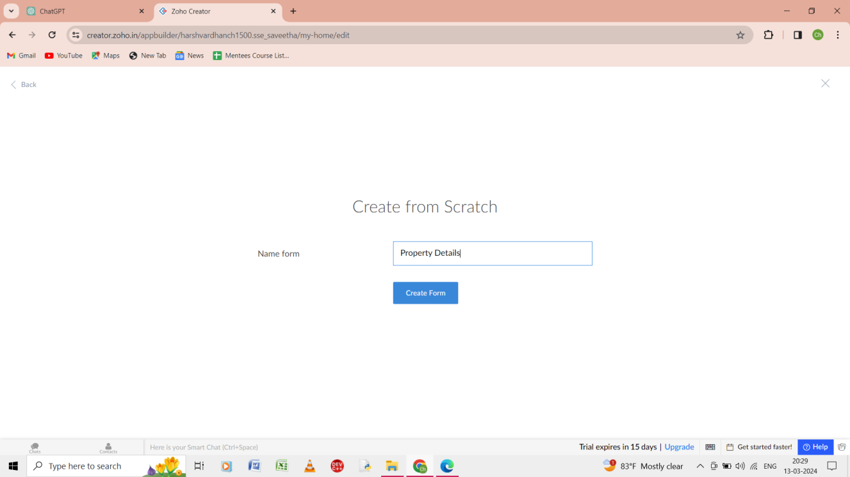

Step 1: create from scratch and give the form name as property details.

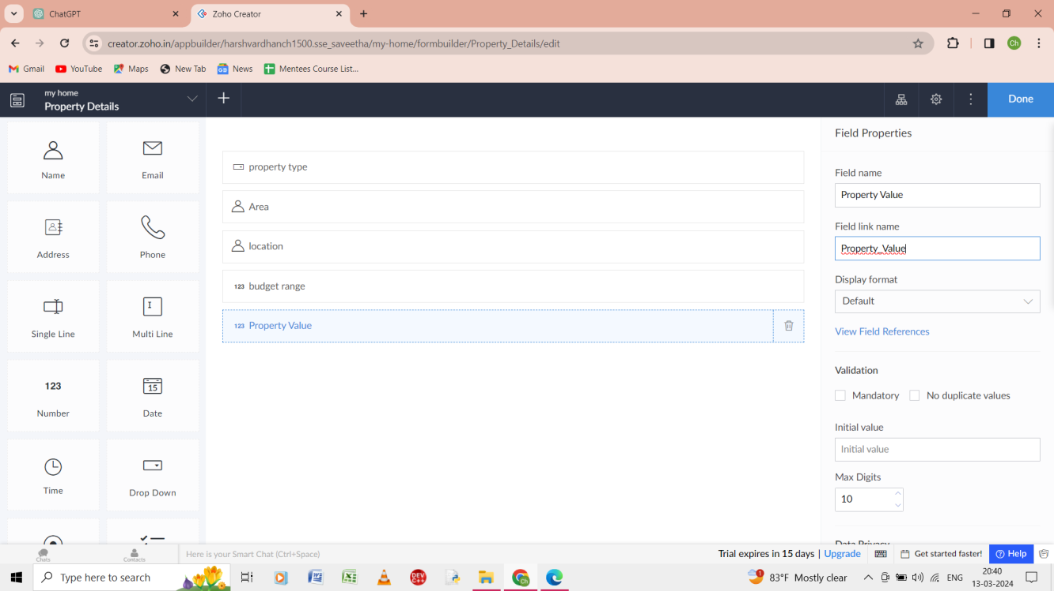

Step 2: give the property type, area, location , budget range, and property value of the form of property details.

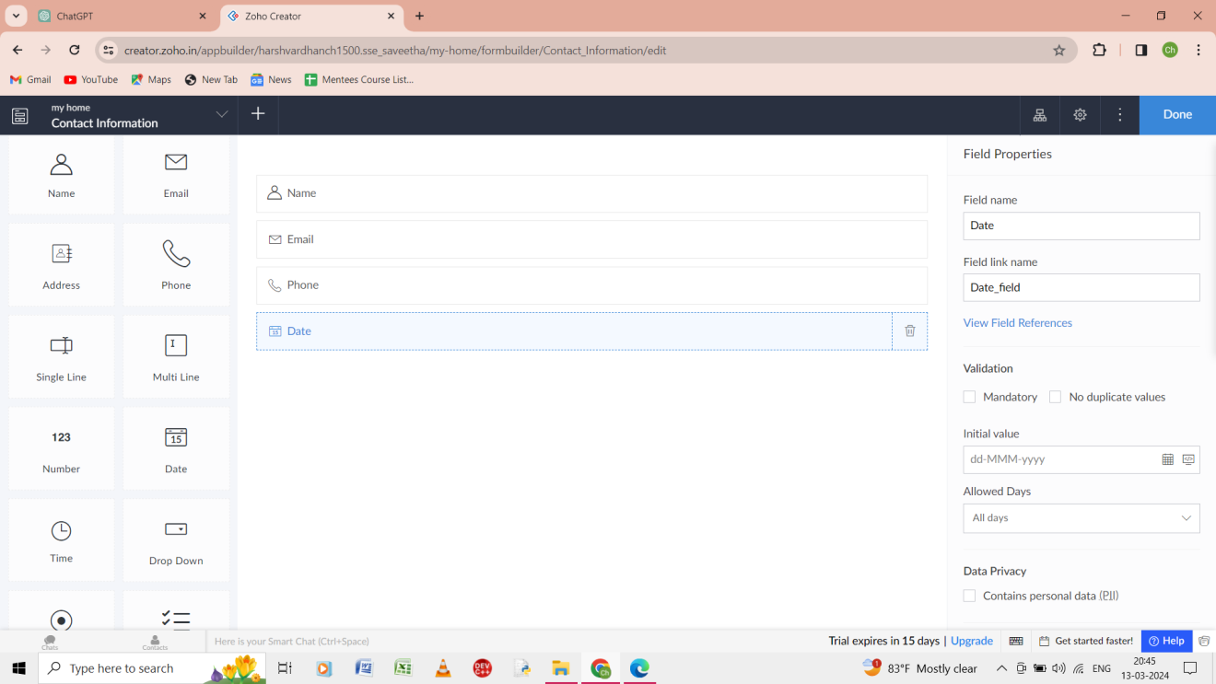

Step 3: Give the contact information as the form and the ouput is shown.

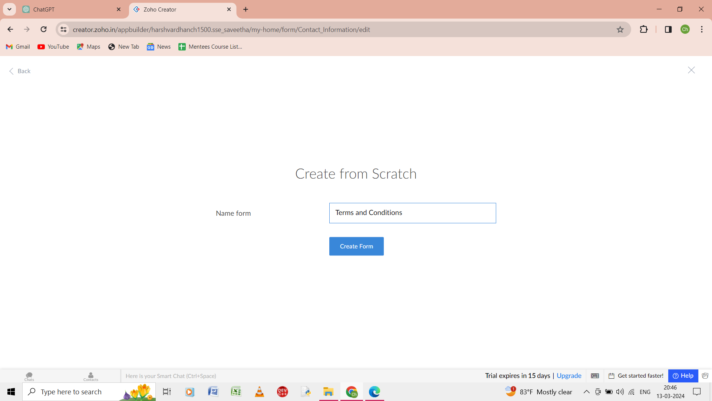

Step 4: from the scratch give the form as terms and conditions.

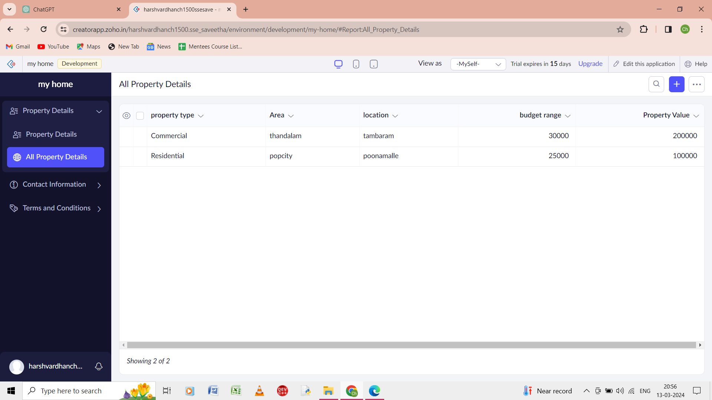

Step 5: the output of the property details is shown .

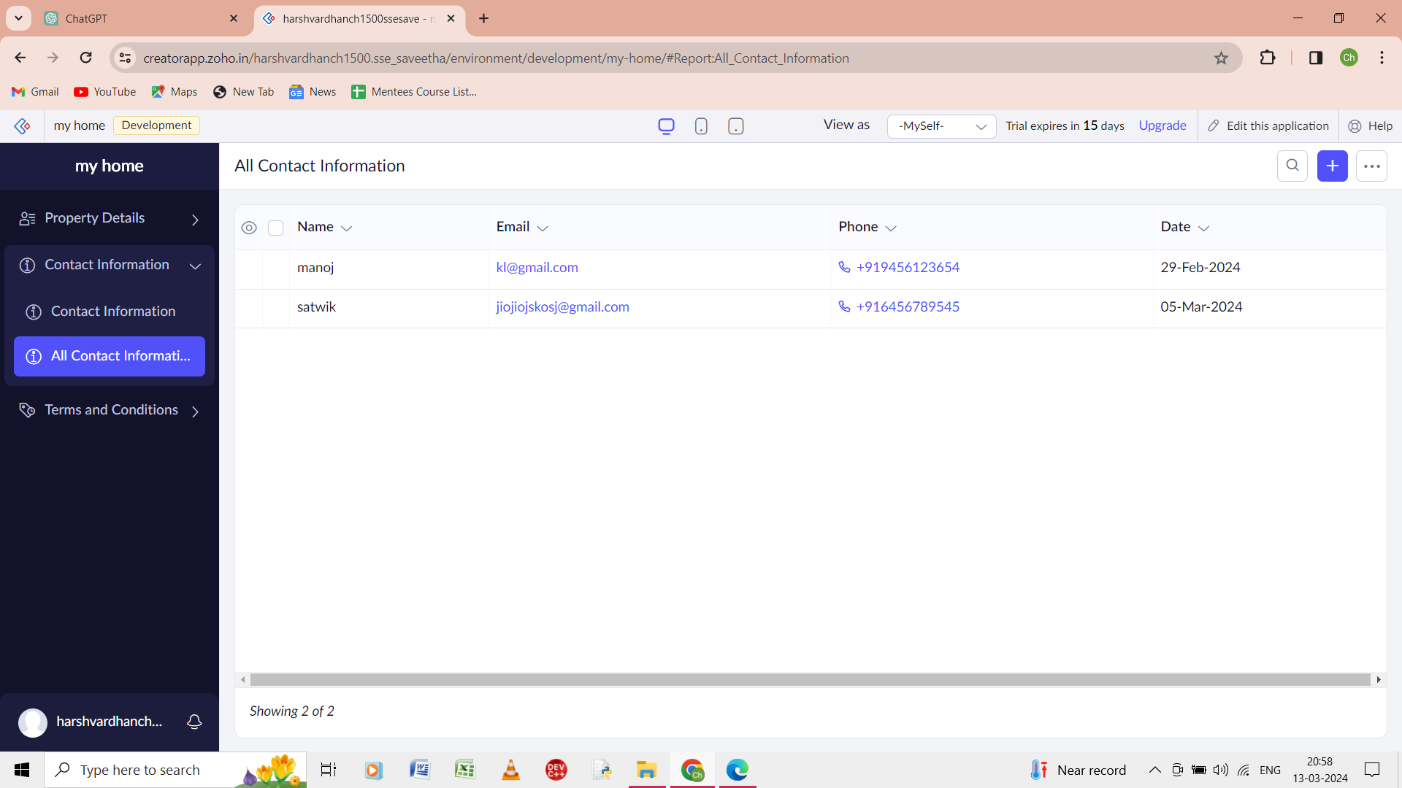

Step 6: the output of the form of contact information is shown.

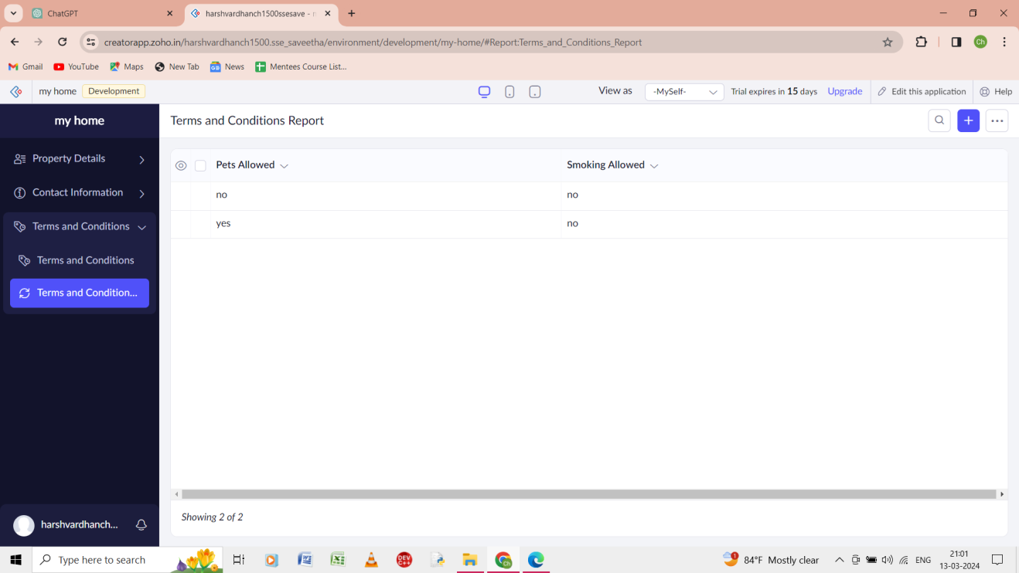

Step 7: the output of the form of the terms and conditions is shown.

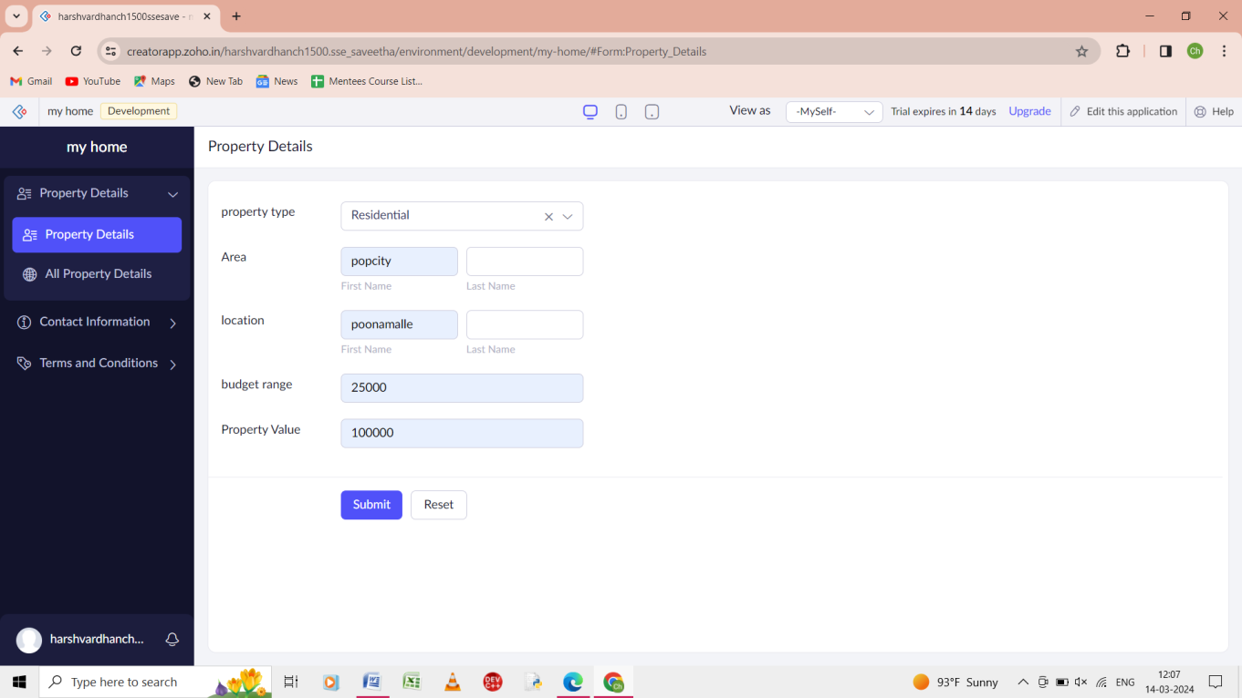

Step 8: the input of the form of the property details is given.